Prairie DuPont Post 485
Standard Operating Procedures
and Employee Handbook
for
Post Canteen
As approved by the Post Membership
Original Date Approved:
Revised as of: Revised as of:
Revised as of:

Prairie DuPont Post 485 Standard Operating Procedure for Canteen
Responsibility: Executive Committee
Approving Authority: Prairie DuPont Post 485 Members
Date Approved:
Next Review Due Date:
Submitted by: Post Commander
Background
In accordance with the Prairie DuPont Post 485 Bylaws, Canteen rules govern the maintenance, control, and operation of the Canteen and the adjacent large hall. Nothing in these rules is intended to be contrary to the Post Bylaws, Department Bylaws, National Bylaws and Manual of Procedures of the American Legion, or the Laws of the United States of America, State of Illinois, St. Clair County, or the Village of Dupo. Those rules and laws shall govern in the case of conflict between the two. No conflict of any section of these rules with those higher rules and laws shall nullify rules contained herein that comply with those laws.

The Executive Committee shall maintain canteen rules. The canteen rules may be amended as necessary for the efficient operation of the Canteen. The recommended amendment(s) will be presented at general Membership meetings for awareness.

Page 2 of 21

Standard Operating Procedures
- Post Canteen House Rules
  - A copy of the Canteen Rules will be provided to all Canteen Employees when hired and after the rules are amended.
    - The Canteen Manager or Executive Committee will ensure that all Canteen Employees are familiar with these rules and will file an Employee Acknowledgement Form (Appendix A) signed by the employee in the employee’s personnel record when they are hired and each time the rules are amended.
    - A copy of the Canteen Rules and the Post Bylaws shall be always kept behind the bar and made available to any employee or Post member upon request.
    - All Members and guests will comply with the Prairie DuPont Post 485 policies and rules and existing federal, state, and local laws.

- Canteen Operations
  - Oversight of the Canteen operations, management, and maintenance is the responsibility of the Executive Committee Chairperson, Executive Committee, and Post Commander.
  - Financial responsibility is under the direct management of the Finance Officer following the procedures for Canteen purchases, sales, and expenditures and are in accordance with Prairie DuPont Post 485 By-Laws.
  - Management of the Canteen and the employed bartenders is the responsibility of the Canteen Manager, Executive Committee Chairperson, and Post Commander, with the advisement of the Post Finance Officer.

- Hours of Operations
  - Normal Operating Hours
    - Monday: 5 pm - 10 pm
    - Tuesday: 5 pm - 10 pm
    - Wednesday: 5 pm - 10 pm
    - Thursday: 2 pm - 12 am
    - Friday: 12 pm - 1 am
    - Saturday: 11 am - 1 am
    - Sunday: 12 pm - 12 am
  - The Chairperson of the Executive Committee may change the Normal Operating Hours in advance of a meeting of the Executive Committee; however the change must be ratified at the next Executive Committee meeting in order to remain in effect.
  - The Canteen Manager may, at their discretion, extend the hours within the Texas Alcoholic Beverage Commission (TABC) Rules and Regulations.
  - Bartenders may, unless otherwise directed by the Canteen Manager, close the Canteen early under the following conditions:
    - The bartender has the option to close before 1000pm at their discretion if the patronage at the canteen drops to three (5) or fewer patrons for more than one (1) hour after 800pm.
      - This rule does not apply to Friday and Saturday nights.
      - Before closure, the Canteen Manager must be contacted.

Page 3 of 21

(3) If the Canteen Manager does not answer and a voicemail is left, then the Chairperson of
the Executive Committee must be informed.
- At the bartender's discretion, patrons may stay on deck after closing hours – if there are no alcoholic beverages being consumed, sold, or in the canteen area.
- The Bartender determines that keeping the bar open would pose a hazard to the Members, their guest(s) or the public or that significant property damage might occur.
- If the bartender on duty has a personal emergency that occurs to them or their dependent(s)that could reasonably lead to a loss of life or significant injury/illness, the Canteen Manager, the Executive Committee Chair, the Commander, or Finance Officer must be notified immediately – or any Post Line Officer in the canteen area. Any Post Line Officer or member of the Executive Committee who holds a current TABC Certification may assume operations of the Canteen until a relief bartender can take over.
- Personal Emergency involving patrons or their dependent(s) that could lead to a loss of life or significant injury/illness. The Bartender determines that keeping the bar open would pose a hazard to the Members, their guest(s), or the public or that significant property damage might occur.
- When ordered to do so by any competent government authority such as the Police, Fire Department, National Guard, Texas Alcoholic Beverage Commission (TABC), etc.
- A prolonged loss of power.
  - The Bartender will notify the Canteen Manager, clear the Canteen of all personnel when power is lost, and inform them that they are welcome to return once power is restored.
  - If power remains out for longer than 30 minutes during periods of darkness, the bartender may close the Canteen.
  - During daylight hours, the bartender will remain at the premises and re-open the Canteen upon restoration of power. If the bartender is informed that power will not be restored during their shift, they should contact the Canteen Manager for further directions.

- Canteen License
Prairie DuPont Post 485 operates under a State of Illinois liquor license. Therefore, the rules and regulations about that license must be strictly and uniformly enforced. In addition, certain other rules and regulations are established to ensure the safety, welfare, and goodwill of our Members and guests. Prairie DuPont Post 485 is an open post – the public is authorized to patronize the post for all events (special events, post open house and advertised meals, pool tournaments, etc.), however, all non-member(s) must follow the established guidelines.
The following rules govern the control and sale of alcoholic beverages and patron use of the bar area. Primary enforcement of these rules is the responsibility of the Bartender on duty.
  - Under “NO” circumstances will Liquor (Any beverage above 17% alcoholic content) be stored on/or kept on the premises of the Post.
  - No Bring Your Own Bottle “BYOB” is allowed.
  - All bartenders, Canteen Manager, Post Commander, Senior and Junior Vice Commanders, and Finance Officer will attend TABC training and be familiar with the TABC rules concerning the sale of alcoholic beverages and food handling.
  - Certificates are to be maintained, current, and on file in the Information Binder behind the bar.

Page 4 of 21

- All patrons will obey the directions of the bartender on duty. Conflicts will be resolved by the
Canteen Manager, House Chairperson, and Post Commander (in that order).
- The Bartender has the exclusive and final right to refuse service to anyone and may remove any patron from the Post until the next business day for misconduct.
  - The Bartender has the right to refuse service to anyone and may remove any patron, member, or guest from the premises until the next business day for misconduct or intoxication. Bartenders do not have the authority to “ban or bar” a patron, guest, or member from the Canteen privileges for any period other than for the immediate 24 hours following an incident as described herein.
    - No sales to any intoxicated person.
    - If an intoxicated person arrives on the post grounds, we will refuse service and they will be asked to leave the post grounds.
    - If any person refuses the request to leave from the bartenders, it will automatically result in a 30-day ban.
  - The Post Commander has the authority to “bar or ban” a patron/guest “Indefinitely or Permanently” and must only inform the Executive Committee and General Membership at the next regularly scheduled meeting.
  - If the incident involved a member, the matter will be deferred until the next regularly scheduled General Membership meeting, at which time the Membership will decide the matter. An incident report must be filed with the Canteen Manager or Executive Committee within 24 hours.
  - Any person observing misconduct deemed a serious offense by any person must notify the bartender, who must, in turn, notify Post Officers. The Executive Committee may take disciplinary action against any member (as defined above) for improper conduct (e.g., making obscene gestures, being rude to the bartender or patron, etc.).
- Alcoholic beverages may only be consumed at the Post during normal Canteen hours and may only be consumed within the confines of the Post building and enclosed yard. The Commander can make an exception for special and outdoor Post events.
- There will ABSOLUTELY be no type of illegal substance allowed on the premises of the post.
- No person under 21 will be served, or is to consume, alcoholic beverages.
  - All persons will show proof of age when requested by the bartender, in accordance with guidance set forth by TABC.
  - If any person suspects that an underage individual has entered the Post or suspects that an underage individual is attempting to purchase or is consuming alcoholic beverages on the premises, they will notify the bartender who will check their identification.
  - No person under the age of 21 will be permitted to sit at the bar at any time.
- Bartenders are not allowed to consume alcohol while on duty. A violation of this rule is grounds for immediate termination of employment and, if applicable, Section 9 of the Bylaws.
  - Bartenders and any paid employees are prohibited from being intoxicated on post property. The Executive Committee will handle violations.
  - While Post Officers and Executive Committee Members cannot be absolved of their responsibilities to the Post while consuming alcoholic beverages as patrons, they should defer making Post decisions as deemed appropriate.
Page 5 of 21

k) All Members and guests will comply with Prairie DuPont Post 485 policies and rules, and existing
federal, state, and local laws.
- Patrons will stay in the Canteen area and are not allowed in the offices, kitchen, and storage areas, behind the bar or any room not in use unless they are authorized to be there by the bartender, Canteen Manager, or other Post official. Post official means post senior officer such as Post Commander, Senior and Junior Vice Commanders and Finance Officer.
- Renewal of all licenses, permits and fees as approved by the Membership is the responsibility of the Finance Officer.
- Incidents and Issues
  - The bartender or any member observing misconduct by any Member or Patron must immediately notify the Canteen Manager, Executive Committee Chairperson and/or the Post Commander.
    - The person observing the misconduct will immediately complete an Incident Report Form (see Appendix G), if a disturbance is created on the premises by the person(s) who is creating a problem.
    - A TABC Breach of Peace Report (Appendix H) Form ENF 5122 will be submitted if any of the following has occurred:
      - If the altercation involved physical contact (shoving or fighting) with or between individuals on your premises
      - Causes bodily injury to another person.
      - Threatens another person with a weapon.
      - Discharges a firearm on the premises of the permit or license.
      - Destroys the permittee's or licensee's property, if the incident is reported by the permittee or licensee to a law enforcement agency.
      - Law enforcement or emergency medical services personnel respond to the premise
    - The person completing the Incident Report Form will also complete and submit TABC Form (ENF 5122 – Breach of the Peace Report) as soon as possible and no later than five (days).
      - If any of the above incidents involved the following:
        - Shooting
        - Stabbing
        - Serious bodily injury
        - Someone has been killed
- You will also complete and submit TABC Form (ENF – Breach of Peace Report) as soon as possible and no later than eight (8) hours. The above incidents are directly out of the TABC Rules Section 35.32.
- The reports will be turned in to the Finance Officer for submission on the Alcohol Information Management System (AIMS) and provide a copy of all reports, and written documentation to the Post Adjutant.
b) The Post Commander will take immediate action as deemed necessary. The person(s) making the report will turn it into the Bartender, Canteen Manager, Executive Committee Chairperson and/or Post Commander. The Post Commander will review the incident and may take disciplinary action against any member(s) as defined above for improper conduct. Further information is outlined in paragraph 8 (Disciplinary Action Imposed on Post Members). Further actions are outlined in paragraph 8 (Disciplinary Action Imposed on Guest, Member Guest, and Special Guest).

Page 6 of 21

- When answering the Post’s telephone, the bartender will attempt to answer the caller’s question(s). If you cannot properly answer the question, you can refer the caller to the Canteen Manager, a Post Line Officer, Executive Committee Chairperson, or Commander.
- Bartenders will report all incidents and information when they become aware of any information about post Members (notice of a member’s hospitalization, illness, or death) to a Post Officer and Canteen Manager. The Commander will then inform the appropriate committees.
- Any person that seems to be under stress or that asks for or needs some type of counseling, immediately contact any available post member, officer or Executive Committee chairperson/member.

- Post Kitchen Rules
  - Any paid employee or American Legion/Auxiliary Member working in the kitchen must have a valid Food Handlers Card/Certificate (FHC) permit. Copy of permit/certificate be on file in the information book in the canteen area.
  - No one may remove any items from the kitchen without the permission of the Executive Committee Chairperson or person assigned control of the kitchen.
  - Meal announcements. Scheduled meals will be announced in the monthly Post calendar. Meals are served on a first come, first serve basis unless advertised. Pre-selling of certain meals may occur.
  - All kitchen workers must comply with the specific Kitchen Rules posted in the kitchen area and those established by the St Clair County Health Department.
  - Any item used or borrowed from the kitchen and or canteen must be cleaned before returning, if lost or damaged, the individual will replace item(s) borrowed.
  - It is the responsibility of the lead person of scheduled event(s) to ensure that all kitchen items utilized to support their event are properly cleaned and stored in their proper locations.

- Miscellaneous Post Canteen House Rules
  - Animals. Leashed animals of Members and guests shall be permitted access to the Post except when food is being prepared and meals are being consumed in the building.
  - Service Animals. Service animals are to be allowed access in accordance with the Americans with Disabilities Act (ADA).
  - Weapons. Weapons are prohibited inside the Post. The Bartender, Canteen Manager, or any Post Officer, at their sole discretion, may designate an object as a weapon and ask that the object be removed from the premises.
    - Exceptions include:
      - Utensils such as knives that are the property of the Post for the use in preparing food.
      - Pocket knives of reasonable size. This rule is subject to the discretion of the Bartender on duty, or any Post Officer as they see fit.
      - Weapons normally used in the line of duty carried by Law Enforcement Officials.
      - Weapons that belong to the Post or are obtained/authorized by the Post for ceremonial purposes.
Page 7 of 21

- Attire. Proper attire is required for all staff, Members, and guests while in the Post. Those who
wear clothing that is determined to be too revealing or containing offensive symbols or language or otherwise unacceptable may be asked by the on-duty Bartender, or any Post Officer, to leave the Post property. Footwear must be always worn.
- Jukebox. The use of the Juke Box will be discontinued during all Post meetings, Presidential TV addresses or Government broadcasts that contain information of major impact to the public and all major sporting events involving teams designated through action by the Members in during the regular season and all playoffs and championship games.
  - The Bartender or any Post Officer will enforce this rule.
  - The volume of the jukebox shall be maintained at a level that does not interfere with normal conversation in the Canteen. If the Hall is rented for an event, the jukebox volume will not interfere with the event being hosted – this is at the discretion of the bartender or any Post officer.
- Televisions. The Bartender shall control the use of all Canteen TVs. The TV shall be on the station broadcasting programming based on the majority of the Post Members present. The volume of the TV’s shall be muted or maintained at a level that does not interfere with normal conversation in the Canteen. There will be ABSOLUTELY NO partisan political programs shown on Post television monitors. Non-partisan programs such as the annual State of the Union address by the President of the United States and programs such as announcing election results may be shown.
- Signage. Posting of signs within the confines of the Canteen must be approved by the Canteen Manager/Executive Committee Chair.
- Children/Minors. All children in the Post will always be accompanied and supervised by their parents or responsible adult while on the Post premises. The parent or responsible adult shall be responsible for the behavior of minor children in their charge. Parents and/or responsible adults whose children become unruly, disruptive, or disobedient will be asked to take their children and leave the premises. Children will not be allowed to play pool unless under the direct supervision of a parent/adult, also playing. Children are not to play any other gaming systems in the canteen.
- Bearing. Bartenders shall not discuss any job-related issues with anybody but the Executive Committee or Canteen Manager. Bartenders shall not engage in any conversation with patrons deemed to be unfavorable, negative, or derogatory in nature relating to other Members, officers, the Post or any other level or aspect of the American Legion.
- No sales to any intoxicated person.
  - If an intoxicated person arrives on the post grounds, we will refuse service and they will be asked to leave the post grounds.
  - If any person refuses to leave, it will automatically result in a 30-day ban.
- Smoking: Smoking is not permitted in the canteen, Post home or within 10 feet of any entrance/exit. This shall also include e-cigs and/or vaping.
- Disciplinary Action Imposed on Post Members. Procedures for invoking disciplinary action against a member of Prairie DuPont Post 485, responsibilities of the accusing party, the Executive Committee and the rights and process of appeal of the accused Post member for violations of the House Rules are outlined in this section. All incidents will be recorded using Appendix “G” – Incident Report Form.
Page 8 of 21

- All incidents will be reported using the Incident Report Form (Appendix-G) and TABC Form ENF
5122 (if required) and reported. Be sure you print clearly and gather all information required by the form.
- Any member, guest, or employee of the Post may file a complaint with the Executive Committee against any patron, member, employee, officer or appointee of the Post that they believe have violated the House Rules.
- Complaints against Post Members will be submitted to the Executive Committee Chairperson for review must be in writing and signed by the person bringing the complaint.
- Any member who strikes another person in a non-self-defense manner will be immediately ejected from the Post for 30 days, pending the finding of the Executive Committee. This is an incident that is reportable using Incident Report Form and TABC Breach of the Peace Report (TABC Form ENF 5122) and reported in accordance with para 4 q above and Appendix G and H.
- Racial, demeaning, or abusive language or behavior shall not be tolerated. Any instance will result in immediate ejection from the Post for 24 hours by the Bartender or any Post Officer present. Any continued misconduct by any member may result in a restriction of Canteen privileges for up to sixty (60) days as a result of a Executive Committee closed hearing of all involved parties. Further or more serious infractions may result in the Executive Committee's recommendation to the Post Commander and general Membership of higher restrictions to include permanent loss of all privileges.
- Any Member of the Prairie DuPont Post 485 is subject to a formal complaint for misconduct or abuse of these rules will not be permitted to participate in the committee’s proceedings on the matter.
- Expelling a patron until the next business day is the maximum penalty that may be imposed by the Bartender. The on-duty Bartender will submit a detailed incident report (Appendix G) of the incident to the Executive Committee Chairperson, via the Canteen Manager, within 24 hours. If no further disciplinary action is deemed necessary, the report will be held on file for a maximum of 180 days. Provided no other incidents occur during that period, the report will be destroyed, and no record of the incident will be maintained, and the circumstances of the incident may not be used against a member any time after that.
- The Executive Committee Chairperson or the Post Commander may remand the matter to the Executive Committee for further action or may evoke additional disciplinary measures until the full Executive Committee can take up the matter.
- The Post Commander may overrule any measure imposed by the Executive Committee Chairperson. The Membership may override any measure imposed by the Post Commander on a Post member at the next regular scheduled meeting or at a special meeting called to review the actions of the accused.
- The maximum penalty that may be imposed on an accused member by anyone other than the Executive Committee or Post Commander is a suspension of Post privileges until the next scheduled meeting of the committee. If no meeting occurs in any given month, the maximum penalty that may be imposed is a suspension of Post privileges for 30 days for the first offense.
- Any member accused of violating the rules and subject to disciplinary action brought before a hearing of the Executive Committee will be allowed to present their case in person before the committee. The accused, as an option to appear in person, may present their case to the committee in writing.
Page 9 of 21

l)
The accused may appeal any decision of the Executive Committee in writing to the Post Members.
The Post Members may refuse to review the case, make modifications to, or overrule the committee's decision. The Post Membership decision is final and may not be appealed.
Page 10 of 21

Hiring, Counseling, Suspension and Termination of Canteen Employees.
- Canteen Manager. The Executive Committee shall hire a Manager to operate and maintain the Canteen. The Manager shall be responsible to the Executive Committee Chairperson and the Post Commander.
- Managing the Canteen Manager. The hiring, counseling, suspension, and recommendations to terminate the Canteen Manager shall be the responsibility of the Executive Committee Chairperson. Suspension of the Canteen Manager may only occur with the consent of a majority of the Executive Committee. However, the Executive Committee Chairperson with the approval of the Post Commander (or Sr. Vice Commander, in his absence) may temporarily suspend the Canteen Manager until the Executive Committee can meet and take up the matter. Unless the suspension occurs within ten (10) days of a regularly scheduled Executive Committee Meeting, the Executive Committee Chairperson will call a Special Executive Committee Meeting to address the issue. Suspension of a member requires a majority decision of the Executive Committee.
- Hiring of Bartenders: Hiring Canteen bartenders is the responsibility of the Canteen Manager with final approval by the House Executive Committee. The new hire will be placed on a 90-day probation period. The new hire will be given a copy of the code of conduct and will sign an Employee Acknowledgment Form (Appendix A). All bartenders must obtain and maintain their TABC certification before working the bar.
- Counseling of Canteen Bartenders: The counseling of Canteen bartenders is the responsibility of the Canteen Manager or House Executive Committee. Counseling will be documented using Prairie DuPont Post 485 Employee Counseling and Discipline Form (Appendix B). The Canteen Manager or House Executive Committee will document the events that form the basis for counseling and/or disciplinary action and the action taken (warning, suspension, or termination etc.). The counseled employee will be offered the opportunity to comment on the appropriate section of the Employee Counseling and Discipline Form. The Canteen Manager or Executive Committee will seek the employee’s signature on the form, which will indicate their awareness of the counseling/ disciplinary action. If the employee refuses to sign the form, the Canteen Manager or House Executive Committee will stress that their signature does not constitute an admission of wrongdoing but merely an acknowledgment of the action taken. If the employee still refuses to sign the form the Canteen Manager or House Executive Committee will note this on the form.
- Suspension of Employees: Disciplinary action(s) resulting in the suspension of Canteen employees is the responsibility of the House Executive Committee. However, the Canteen Manager with the consent of the House Executive Committee may suspend an employee until the House Executive Committee can meet to take up the matter. If the suspension occurs more than 10 days before a regularly scheduled House Executive Committee meeting, the Executive Committee Chair will call a special Executive Committee meeting to address the issue. Extended suspension of an employee requires a majority decision of the Executive Committee. It is the responsibility of the Canteen Manager to make regular reports to the Executive Committee of all counseling and disciplinary actions taken. In the absence of a Canteen Manager, the responsibility of making the report falls on the Executive Committee Chair.

Page 11 of 21

- Suspension and Termination of Employees. Disciplinary action resulting in the suspension or termination of canteen employees is the responsibility of the Executive Committee Chairperson and the Commander. However, the Canteen Manager, with the consent of the Executive Committee Chairperson and Commander, may suspend an employee until the Executive Committee can meet to take up the matter. Unless the suspension occurs within a majority decision ten (10) days of a regular schedule Executive Committee Meeting the Executive Committee Chairperson will call a special Executive Committee meeting to address the issue.
Termination or extended suspension requires the approval of the Executive Committee. Chairperson and Commander. It is the responsibility of the Canteen Manager and/or Executive Committee Chairperson to make regular reports to the Executive Committee of all counseling and disciplinary actions taken.
- Appeals. Any employee who has been counseled, suspended or terminated will be notified of the time and place of the Executive Committee Meeting that will address the issue. The employee will be allowed to present their case to the Executive Committee and may bring witnesses in their defense. Requests for an appeal to the Executive Committee will be made in writing within thirty (30) days of suspension or termination.
- Canteen Manager / Lead Bartender Duties.
  - [To be completed by the Executive Committee within 60 days of approval by the Members]
Page 12 of 21

Appendices
Appendix A – Definitions
Appendix B - Employee Acknowledgment Form
Appendix C - Employee Counseling and Discipline Form
Appendix D - CODE OF CONDUCT
Appendix E – Incident Report Form
Appendix F - Breach of the Peace Report ENF 5122

Page 13 of 21

Appendix A – Definitions
For these rules the following terms shall be defined as follows:

- Auxiliary Member: Any member of a recognized American Legion Auxiliary or Program that is part of Prairie DuPont Post 485.
- Bar: The counter and any stools placed adjacent (abutting) the counter where alcoholic beverages are served.
- Bartender: The bartender on duty. This is inclusive of a Member who is selling alcohol.
- Canteen Manager: Any person appointed/hired by the Executive Committee to operate the Canteen subject to their instructions.
- Canteen: The area of the Post consists of the canteen area, seating, restrooms, jukebox, and all storage areas for the holding of alcoholic beverages and snacks sold at the bar.
- Grounds: Post property outside of the main building.
- Guest Member: Any visiting Legion or Legion Auxiliary member in good standing that is not a member of Prairie DuPont Post 485.
- Guest: Any person who is not a member, guest member or special guest as defined above who has been invited to visit Prairie DuPont Post 485 by a member in good standing.
- House: The Post quarters and the equipment contained therein.
- Intoxicated: Per Texas Penal Code Section 49.02 defines intoxication as not having the normal use of mental or physical faculties because of the introduction of alcohol, a controlled substance, a drug, a dangerous drug, a combination of two or more of those substances, or any other substance into the body. This is at the sole discretion of the bartender to determine.
- Kitchen: The area adjacent to the Meeting Hall which contains the oven, stove, and other cooking appliances.
- Meeting Hall: The large room on the north end of the building.
- Member: Any Prairie DuPont Post 485 Life member or member of Prairie DuPont Post 485 whose dues are current.
- Minor: Any person who has not attained 21 years of age.
- Parking Lot: Portion of the Post grounds for vehicular parking.
- Patron: Any authorized known person patronizing the Post.
- Post: All property, including facilities, parking areas, buildings, building contents, and grounds, located at 200 S 5th St, Dupo, Illinois 62239.
- Post official: A post senior officer such as Post Commander, Senior and Junior Vice Commanders and Finance Officer.
- Public: All persons not listed as member, auxiliary member, guest member, special guest or guest as defined above.
- Special Guest: All active-duty United States Military/Reserve personnel in uniform or who can show proper military identification.

Page 14 of 21

Appendix B - Employee Acknowledgment Form
I, have received a copy of Prairie DuPont Post 485’s Canteen Employee Code of Conduct. I have familiarized myself with these rules and understand that I am responsible for complying with the rules at all times. I also understand that any time I am unclear of the intent or legality of these rules; I am responsible to seek clarification from the Canteen Manager or Executive Committee Chairperson.
Date:

Signature:
Page 15 of 21

Appendix C - Employee Counseling and Discipline Form
Date:

Employee Name:
Name & Title of Person Conducting Counseling:
Signature of Person Conducting Counseling:
Witness Name:
Witness Signature:
Description of events leading to counseling (required)

Corrective action taken (required)

Employee’s comments (optional at employee’s discretion, indicate “none” if no comments
are desired.)

Employee’s Signature:
(Signature is an acknowledgment that the employee has been counseled and it is not an admission of wrongdoing.)
Page 16 of 21

Appendix D - CODE OF CONDUCT
- Employees and Members of Prairie DuPont Post 485 are expected to act professionally on and off the clock while on Post property, attending a Post event, or posting to social media about Post related content.
  - It will be the responsibility of each employee to maintain a separation from our Members and patrons to be able to conduct responsible service of alcohol and beverages.
  - At no time will an employee, member, or patron discuss Post business on post premises. This includes gossip and/or hearsay from both sides of the bar that involves personnel matters, politics and/or religion.
  - All side work/cleaning duties are to be completed before and after each shift with no exceptions!
  - All employees are required to be on time for the assigned shift and to be responsible for reliable transportation.
  - Employees will be held accountable for the dress code as provided by the Canteen Manager. Any violations of this policy will warrant disciplinary action.

- The following are direct violations of this policy and will result in the termination of all employees involved.
  - Horseplay.
  - Excessive consumption of any alcoholic beverage and use of any illegal drugs while on shift.
  - Possession of any illegal drug/substance on post property.
  - Failure to enforce TABC guidelines or knowingly allowing the perpetration of illegal activities.
  - Gambling.
  - Violation of attendance procedures.
  - Fighting or aggressive behavior toward any Prairie DuPont Post 485 employee, member, or patron.
  - Verbal threats.
  - Theft of any Prairie DuPont Post 485 or Prairie DuPont Post 485 employee’s property, including any product that is not checked into the register.
  - Failure to maintain accountability of draw till or safe contents, including all monies and Post property.

- Unless specified elsewhere in American Legion policies or extraordinary circumstances warrant immediate dismissal, the following progressive disciplinary actions are the standard procedure within Prairie DuPont Post 485:

  - Verbal reprimand – The employee will be told of the infraction and why compliance is important for the wellbeing of all concerned.
  - Written reprimand – The employee will be warned that repeated violations may result in a suspension without pay.
Page 17 of 21
c. Termination – Further indications of a lack of support for Prairie DuPont Post 485 goals
or programs as indicated by rule/policy infractions will not be tolerated.
4. These policies are set out to protect you and your fellow employees. We want Prairie DuPont Post 485 to be the best that it can be. Understand that you accept these policies without reservation when you sign the acknowledgment form after reading them. In other words, you are promising to obey the rules.
Page 18 of 21

Appendix E – Incident Report Form

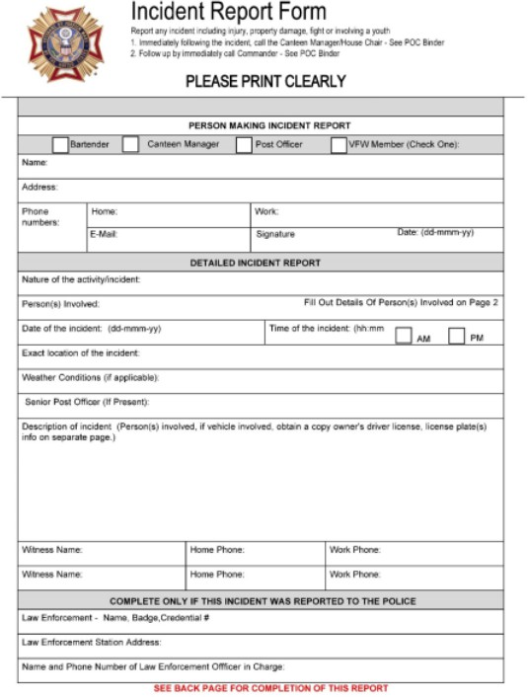

Page 19 of 21

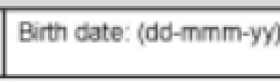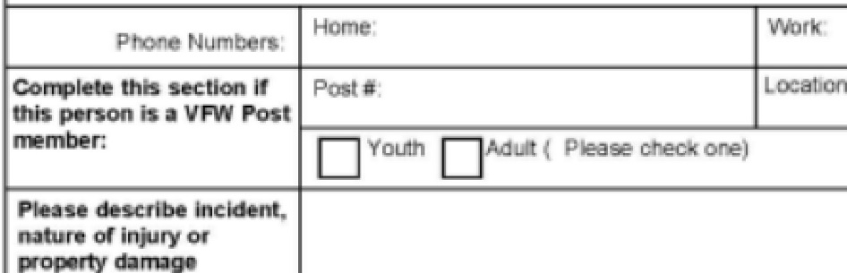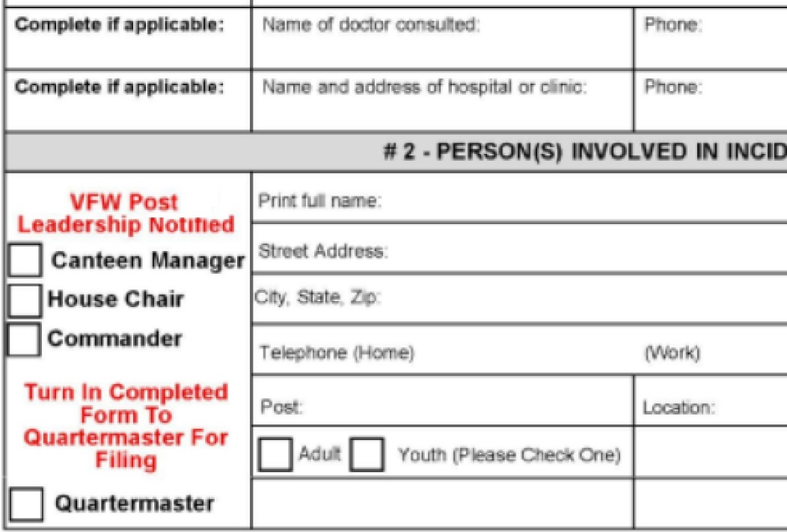

#1 Person(s) lnvolived In Incident

A dr

NT

Page 20 of 21

Appendix F- Breach of the Peace Report ENF 5122

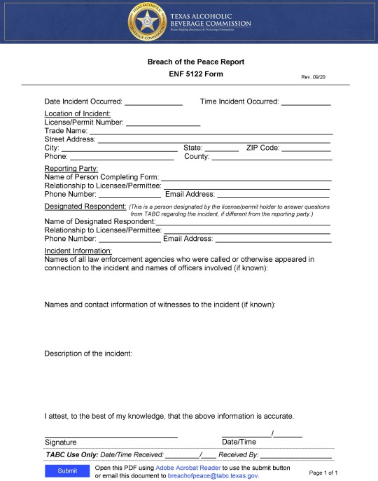

Page 21 of 21

