Event Standard Operating Procedure
Needy Paws Animal Rescue Charity Event

- A fundraising charity event to support the Needy Paws Animal Rescue Group which includes the Prairie DuPont Post 485 American Legion building at 200 S. 5th St, Dupo, IL.
- The event is organized by the Needy Paws group and consisted of groups of “golfers” proceeding from one location to another to “play a hole” and then proceed to the next location/hole on the course. The “tournament” usually begins at 1100 hrs and completes at approximately 1500 hrs in Columbia, IL. Food and drink are available at each hole, provided by the host facility (eg, the American Legion).
- American Legion Post 485 involvement and responsibilities:
  - Event Minimum requirement:
    - Provide one (1) “putting green” with a hole similar to a miniature/putt-putt golf hole. This is constructed, maintained and stored at the Post building.
    - Provide at least one (1) table and two (2) chairs for the tournament judges. This is normally outside in view of the putting green.
  - Post Involvement:
    - Make drinks available to guests and “golfers”. All drinks will be purchased indoors at the Post’s Canteen. No outside drinks will be allowed. Post will ensure adequate staff are available to serve during the event. Generally, at least two (2) bartenders should be on duty.
    - Post can use this event to make available food items for sale to support the Post. Generally, hamburgers, hot dogs and bratwurst sausage sandwiches cooked on a barbeque pit have been made available in the past. Also, a variety of chips/snacks were also available for purchase. Post needs to ensure enough volunteers/staff are available to support this activity, if offered. A good guideline would be at least one (1) pitmaster/cook, at least one (1) server/helper and one (1) cashier to receive all cash for food purchases. Food service should be available starting at 1100 hrs on the day of the event and end at approximately 1500 hrs the same day. A highly visible sign advertising the prices should be posted prominently near the food area.
    - Post also needs to make sure that adequate tables/chairs are available for participants and the the area makes a good impression on the public (Neat, Clean, Orderly).
    - An optional display to make the hole interesting is strongly encouraged, but is subject to availability of decorations and props. A military theme is encouraged due to the veteran organization status, but not required.
  - Food Preparation (Day prior to event):
    - The following items should be staged and available at least one (1) day prior to the event:
      - BBQ pit and at least (2) bags of charcoal
      - At least two (2) sets of serving tongs: one for the pitmaster for cooking and one for serving the cooked food. These are NOT interchangeable and must be used exclusively for each separate task.
      - Adequate condiments for the food being served: ketchup, mustard, pickle relish, mayo/miracle whip, BBQ sauce
      - Pots for boiling brats prior to being grilled
      - “Bussing tubs” for ice to put the condiments in when serving
      - Pans for putting burgers and brats in after they have been grilled prior to serving. An electric roast pan would be preferred if available.
      - Paper plates, towels/napkins for guests
      - Adequate burgers, brats and individually wrapped sliced cheese and/or hot dogs for the number of anticipated customers (must be stored in a refrigerator prior to cooking/consumption)
      - Adequate numbers of hamburger and hotdog buns to match the burgers and brats
      - Recommend having a small amount of utensils/flatware available as needed
      - Have some type of sign available to advertise the prices for foodstuffs

  - Food Preparation (Day of event):
    - The following should be accomplished the day of the event:
      - The BBQ pit should be prepared and lit approximately one hour prior to the designated food service time (approx. 1000 hrs)
      - Brats should be boiled in a pot containing beer and sliced onions approximately one (1) hour prior to the designated food service time (see above)
      - Food should be placed on the grill for cooking in time to be ready at the designated food service time
      - Bus tubs should be filled with ice and condiments and cheese should be placed on tables in the serving area no later than fifteen (15) minutes prior to serving time
      - Paper plates, flatware and napkins should be placed on a table in the serving area no later than fifteen (15) minutes prior to serving time
      - A designated “checkout/pay station” should be designated near the serving area
        - Be prepared to have change available for larger bills
  - Canteen/Drinks:
    - All drinks shall be purchased from the Canteen and served by designated bartenders/staff
    - No outside food or drinks, except water, is permitted
    - No alcoholic beverages may be consumed or transported off American Legion property
    - All drink purchases must be completed with the bartenders on duty, no drink purchases shall be made at the food sales area
  - Food Cashier:
    - Only one (1) person at a time shall be designated as the Cashier and shall be responsible for all funds accountability related to the event
    - All initial cash on hand for the event (change) shall be counted/accounted for by at least two (2) members of the Post, at least one (1) shall be a Post Officer
    - Cashier should ensure that enough cash is on hand to make change for purchases
    - Cashier should ensure that a menu board/price board is available, current, and prominently posted for prices of items near the checkout area
    - In the case of a cashier change for any reason; the off-going cashier, a Post Officer and the on-coming cashier must count/account for all cash on hand at the time of the change
    - At the end of the event, the cashier and a Post Officer must provide a written report of cash received during the event (profit – minus the amount originally provided for change)
  - Volunteers:
    - Any interested person may volunteer their services to support the event. This could be a Legion Member, Auxiliary Member, SAL member, ALR member or member of the community. Volunteers also include anyone serving in any capacity to support the event (eg Pitmaster, Cashier, Food Service worker, general errands, etc)
    - All volunteers should wear some type of identification indicating their affiliation with the American Legion and/or for the event.
    - Volunteers receive no pay for their services for the event. They may be compensated for their service by receiving one (1) hamburger, one (1) bratwurst, or one (1) hot dog, or one of each. They may also receive one (1) soft drink for every two (2) hours worked, alcoholic beverages are not included. Any requested items that exceed the compensation listed above must be paid for at event price.
    - The Legion Event Coordinator/Point of Contact should make a record of who is present for the event and the number of hours worked. (This data is also needed for the Consolidated Post Report). A sign-in/sign-out sheet is highly recommended.

**Location:** 200 S. 5th St, Dupo, IL

PRE-EVENT PREPARATION (Day Prior)
☐ BBQ pit staged and inspected
☐ Two (2) bags of charcoal on site
☐ Two (2) sets of tongs (1 for cooking, 1 for serving)
☐ Condiments: ketchup, mustard, relish, mayo, BBQ sauce
☐ Pots for boiling brats (beer and onions ready)
☐ Bussing tubs for ice/condiment storage
☐ Pans or electric roaster for cooked food
☐ Paper plates, napkins, utensils available
☐ Adequate stock of burgers, brats, hot dogs, buns, cheese
☐ Menu/price sign prepared and printed
☐ Tables and chairs cleaned and staged
☐ Decorations/display (optional, military theme encouraged)
☐ Trash cans and liners in place
☐ Fire extinguisher near grill area
☐ Volunteer sign-in sheet prepared

DAY OF EVENT – FOOD OPERATIONS
☐ BBQ pit lit by 10:00 AM
☐ Brats boiled in beer/onion mix by 10:00 AM
☐ Food on grill by 10:45 AM (ready by 11:00 AM)
☐ Condiment tubs filled with ice and placed by 10:45 AM
☐ Paper plates, napkins, utensils on serving table by 10:45 AM
☐ Cashier station set up with price/menu board
☐ Change box counted and logged (two-person verification)
☐ Food service area kept clean and stocked during event
☐ Pitmaster, server, cashier on duty
☐ Trash emptied periodically

CANTEEN / DRINKS
☐ Two (2) bartenders on duty
☐ “No outside drinks” signs posted
☐ All alcohol sales inside canteen only
☐ Drinks NOT sold at food area
☐ No alcohol leaves Legion property

VOLUNTEERS
☐ All volunteers signed in (name & hours)
☐ Volunteer identification visible (shirt, badge, etc.)
☐ Volunteers aware of compensation policy (1 meal + soft drink/2 hrs)
☐ Coordinator tracks total hours for report

CASHIER RESPONSIBILITIES
☐ Initial cash verified by cashier + Post Officer
☐ Price board clearly displayed
☐ Change funds secured
☐ End-of-shift cash verified by incoming/outgoing cashier + Post Officer
☐ End-of-event report completed (cash received minus starting change)

POST-EVENT CLEANUP
☐ BBQ pit extinguished and cleaned
☐ Tables and chairs wiped down and stored
☐ Food and condiments properly disposed or stored
☐ Trash collected and removed
☐ Cash report filed with Post Officer
☐ Volunteer hours logged for Consolidated Post Report
☐ Area left neat, clean, and orderly

LAYOUT REFERENCE (from event map)
☐ BBQ Grill Area – Outside near Canteen
☐ Cashier Station – Near serving tables
☐ Food Staging – Dart Room
☐ Putting Green – Outdoor event zone
☐ Pop-Up Awning – Over serving area
☐ Display Area – Near entrance or visible to street

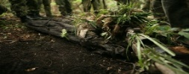
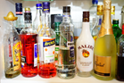
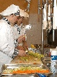
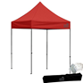

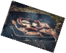

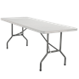
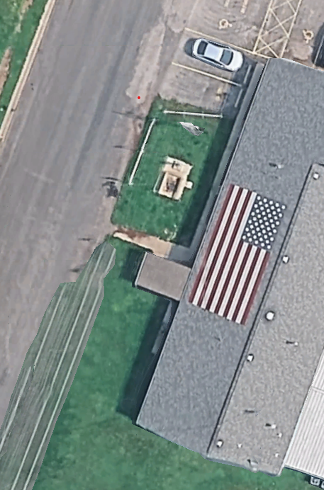
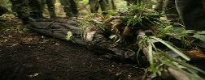
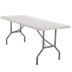
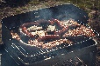
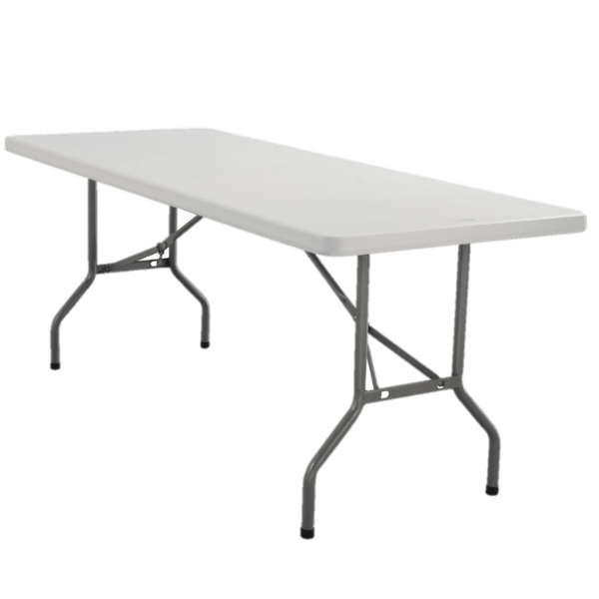
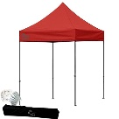
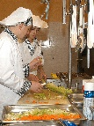

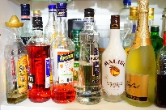

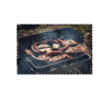
Canteen/Bar
Display area
Food staging area (Dart Room)
Cashier
Serving Table
Pop Up Awning
Putting Green
BBQ Grill Area
Dupo American Legion
200 S. 5th St
Needy Paws Event Set Up
Canteen Entrance

